User Guide — The Powerpoint-er

The Powerpoint-er — User Guide

Overview
The Powerpoint-er generates branded PPTX presentations from text descriptions. It uses a 3-step pipeline: describe your content → review/edit the outline → preview and export slides. The entire export happens in your browser — no server-side rendering needed.
──────────────────────────────────────────────────

How to Use

Step 1: Write Your Brief
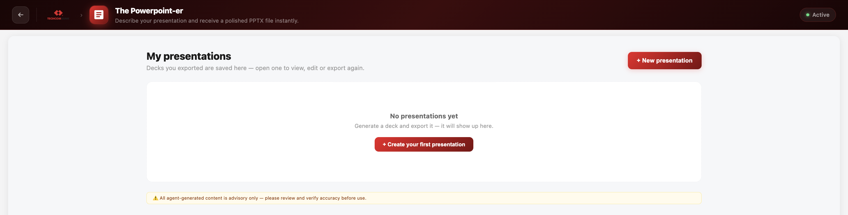
On the left panel, describe the presentation you want. Be specific about: - Topic and audience - Number of slides desired - Key points to cover - Tone (formal, casual, executive)
You can also upload reference files to provide context.
Example prompts:
- "Create a 10-slide deck on AI strategy 2025 for the executive board"
- "Build a quarterly business review with revenue, customer growth, and roadmap"
- "Make a 5-slide onboarding presentation for new engineers"
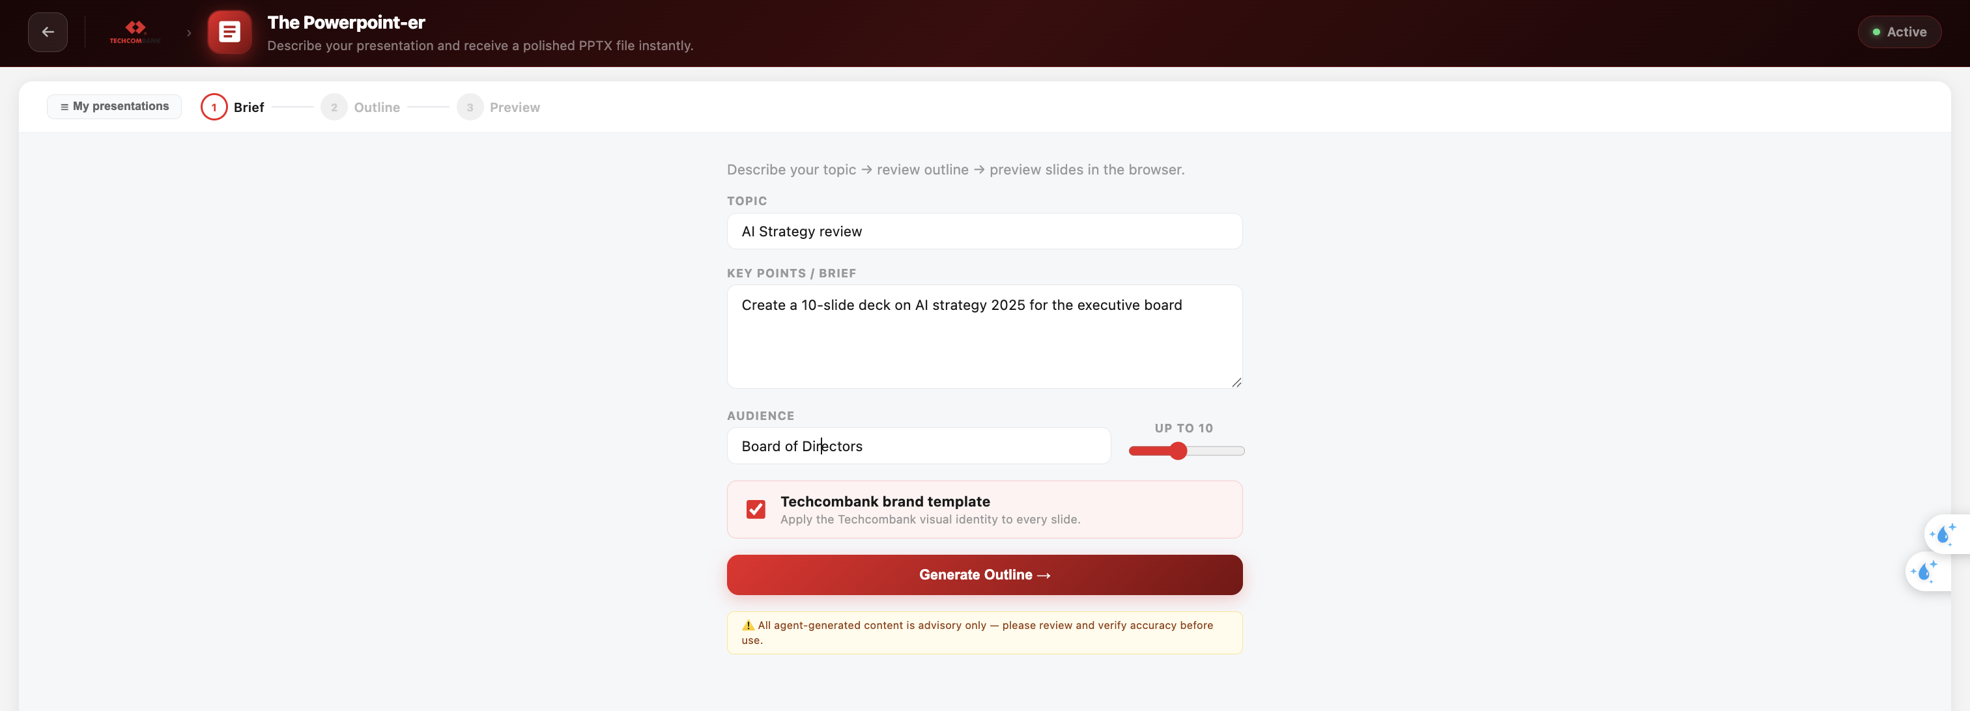

Step 2: Review the Outline
After the AI generates an outline, you'll see an editable slide panel showing: - Cover slide - Content slides with titles and bullet points - Closing slide
You can edit: - Slide titles (click to edit) - Bullet points (click to edit) - Add/remove bullets (+ Add bullet / × to remove) - Add/remove slides (+ Add slide / Remove) - Reorder content as needed (­Up / Down arrows at the upper right)
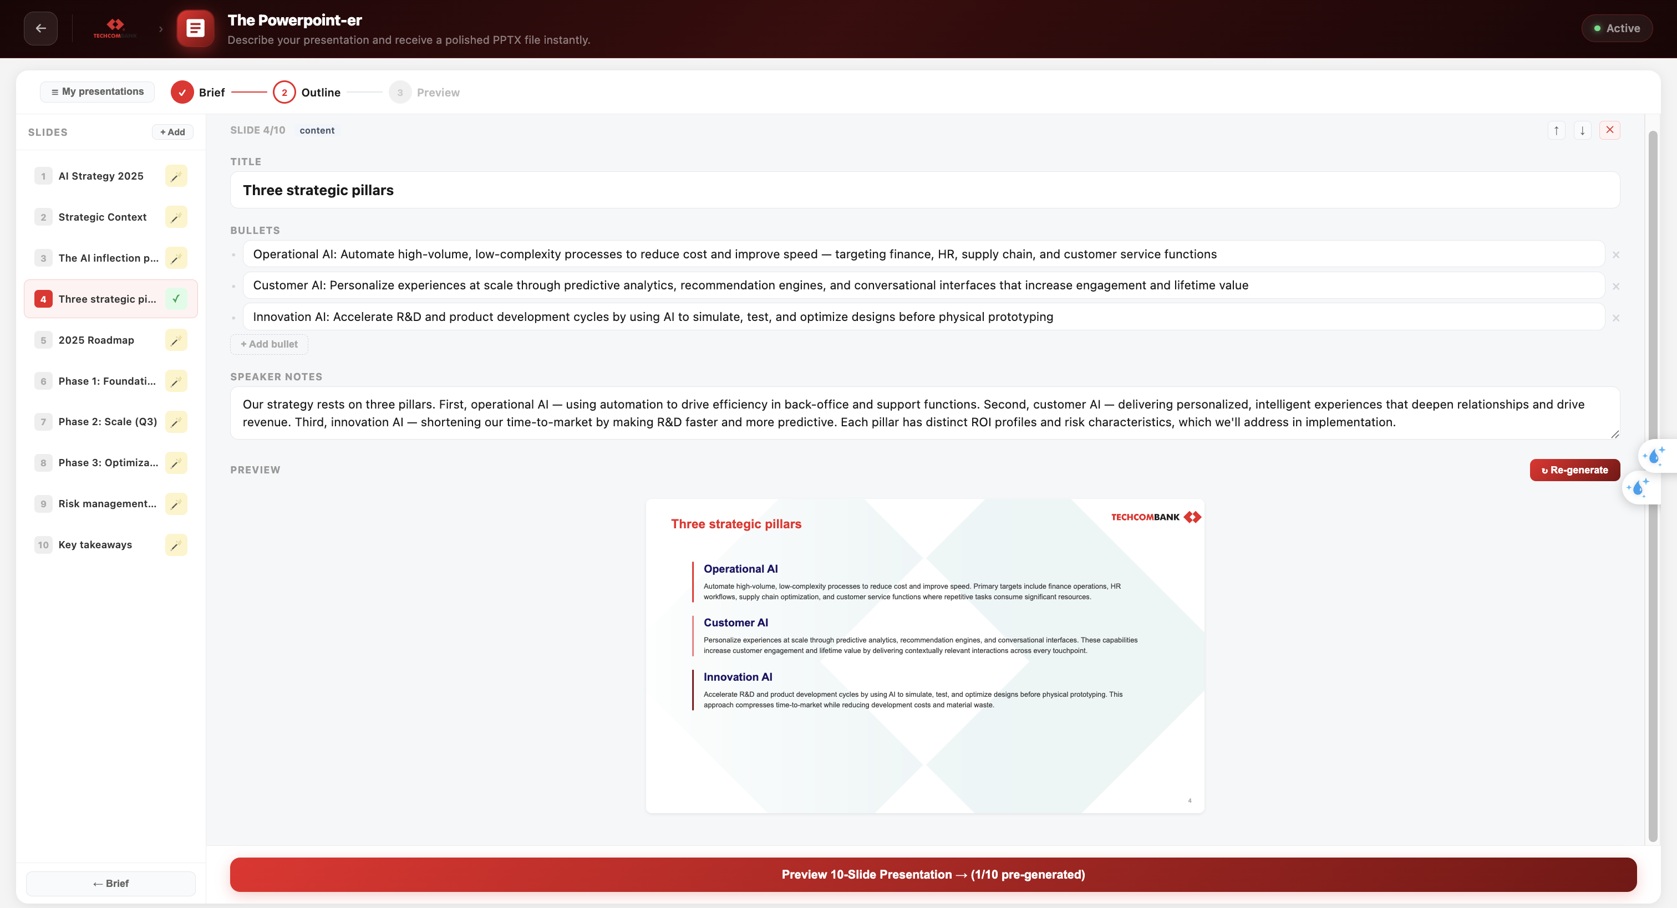

Step 3: Build & Preview
Click "Build Presentation" to generate the full slide HTML. Each slide is rendered as a visual preview that you can:
- Browse through using navigation
- View in a presentation mode
- Edit the outline and rebuild if needed
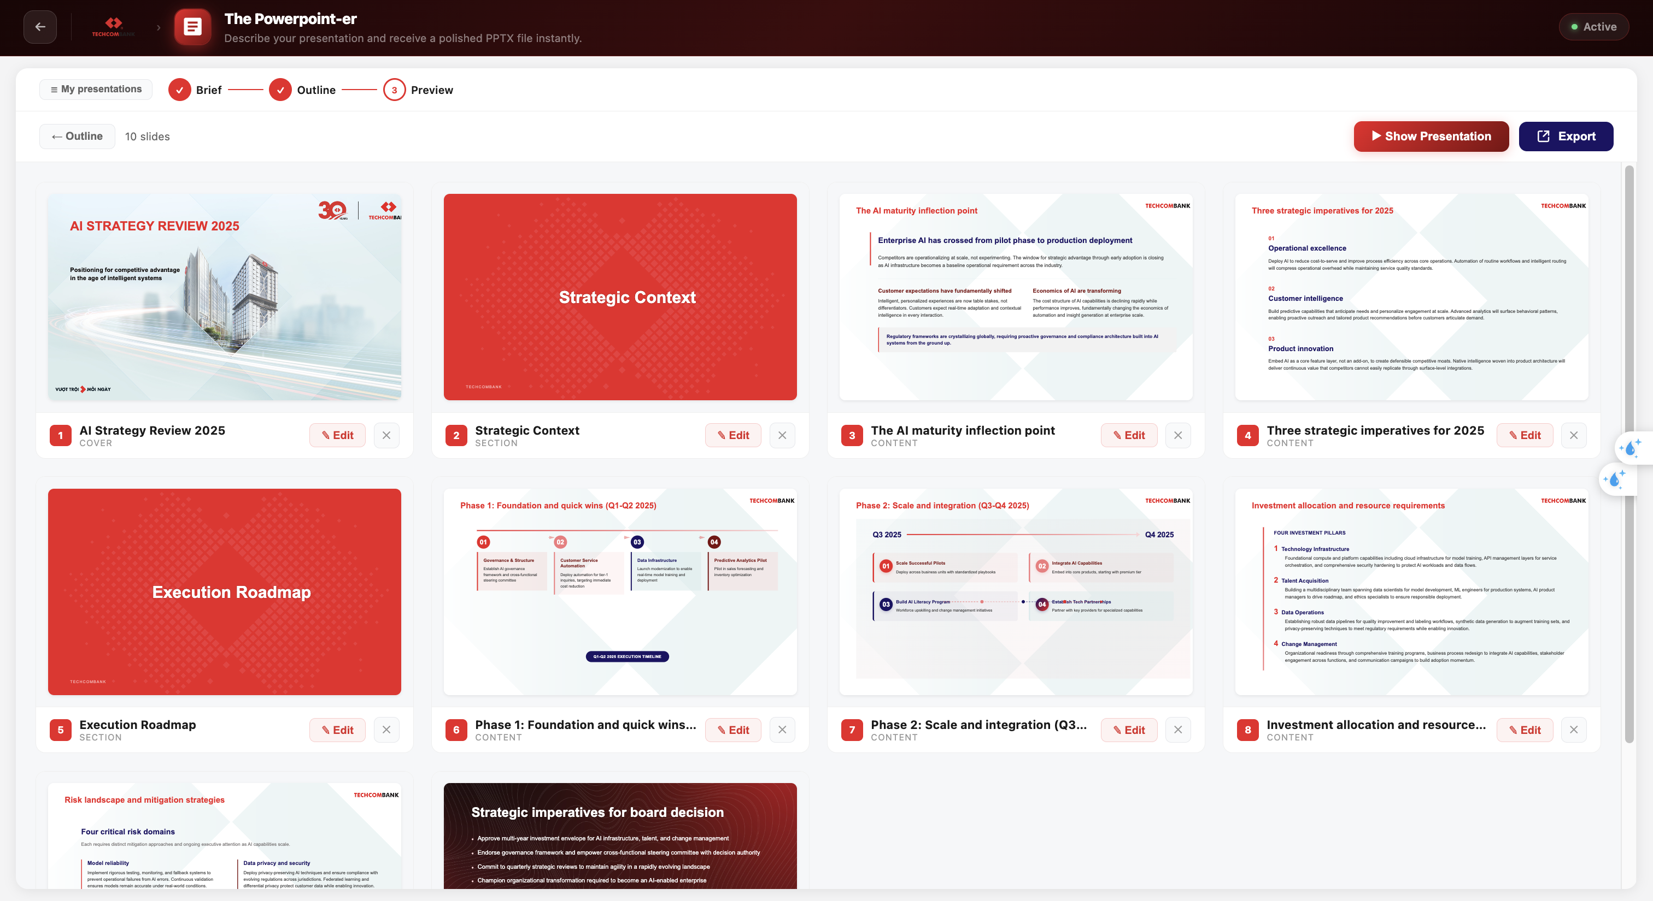
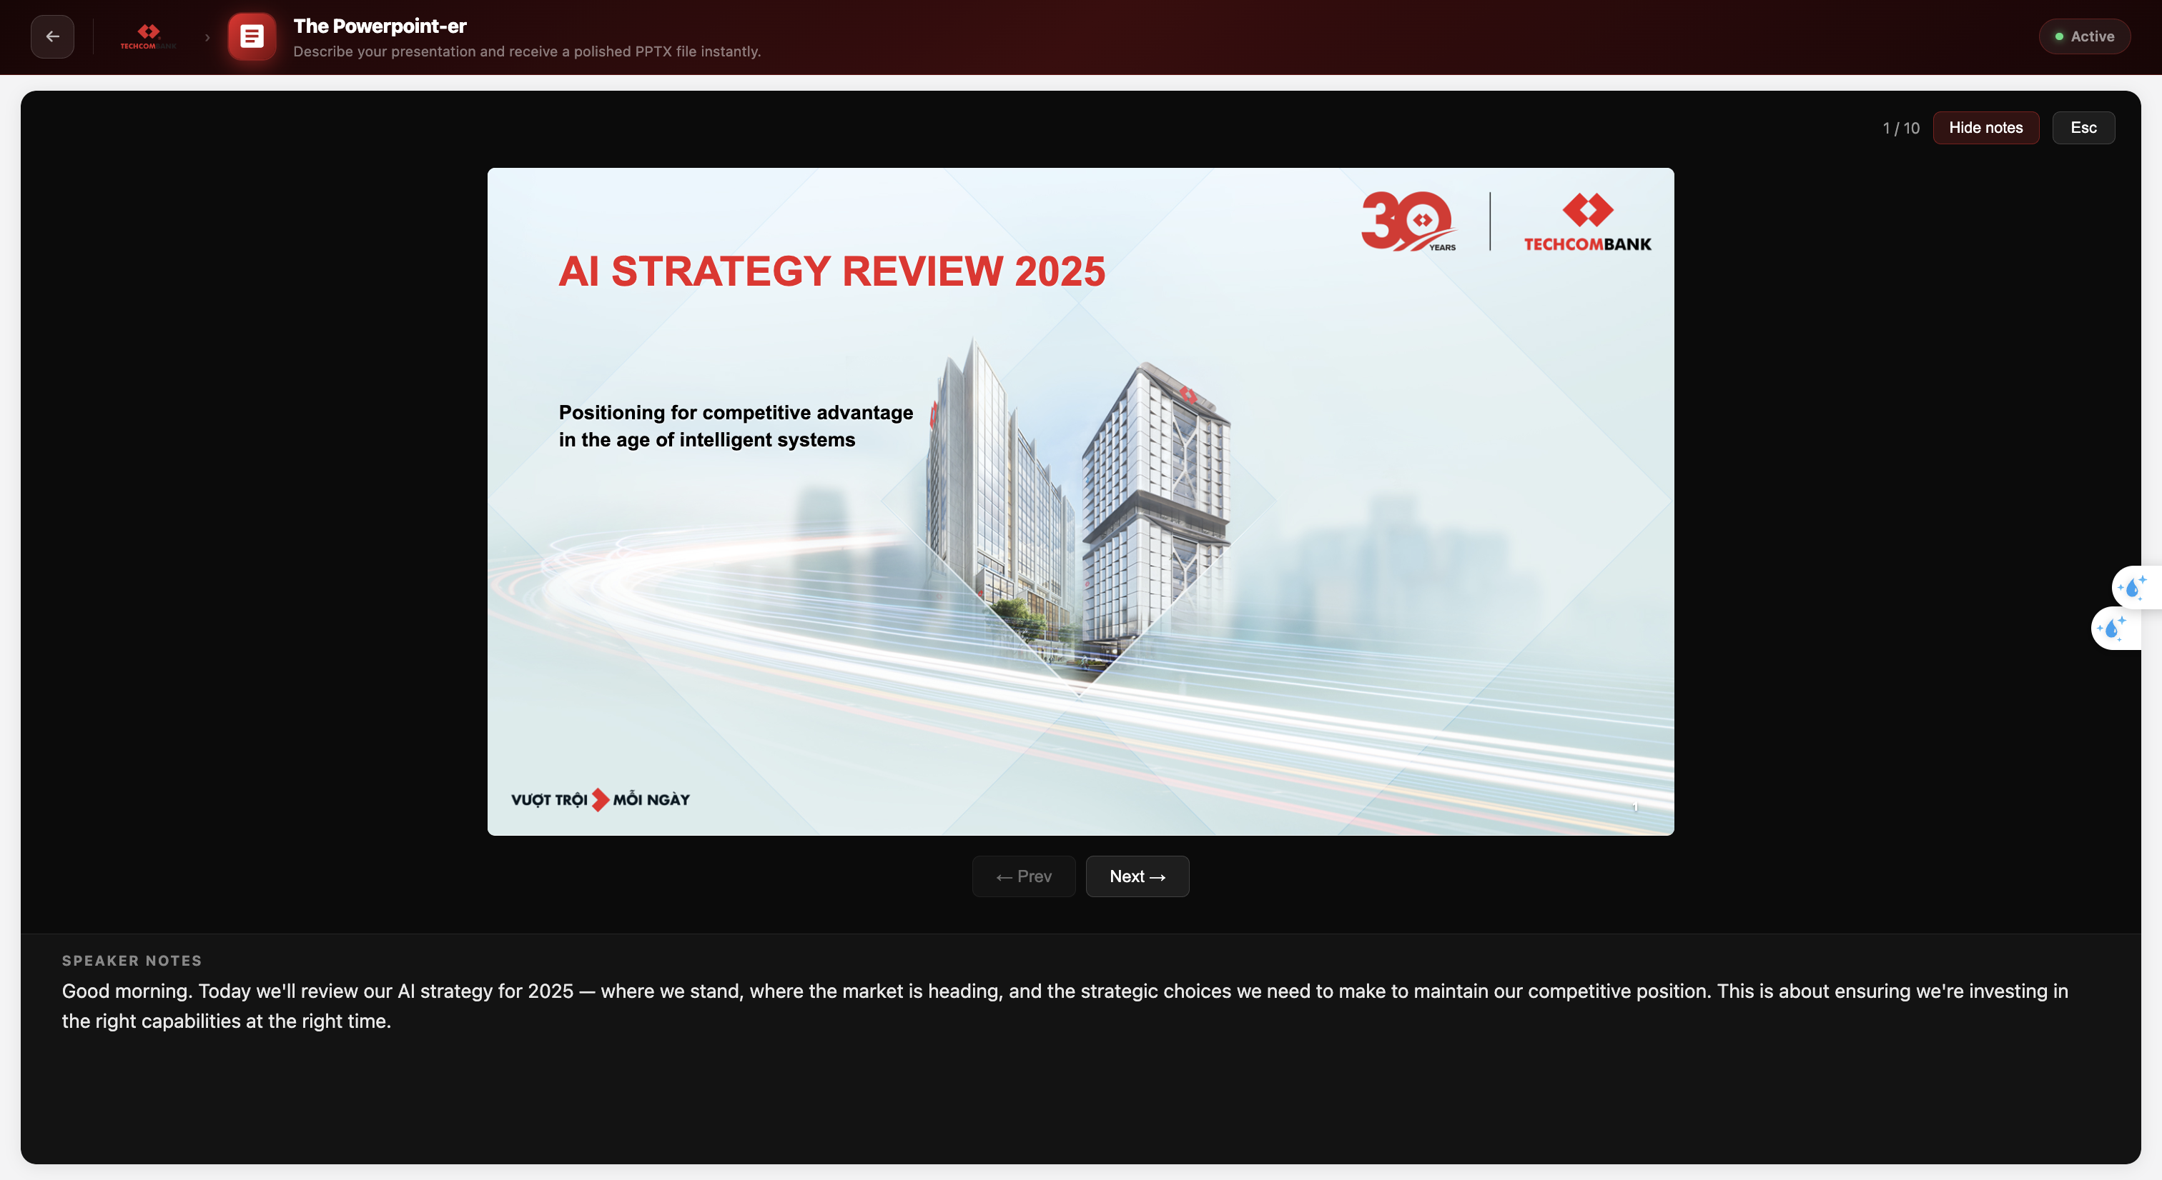

Step 4: Slide Edition
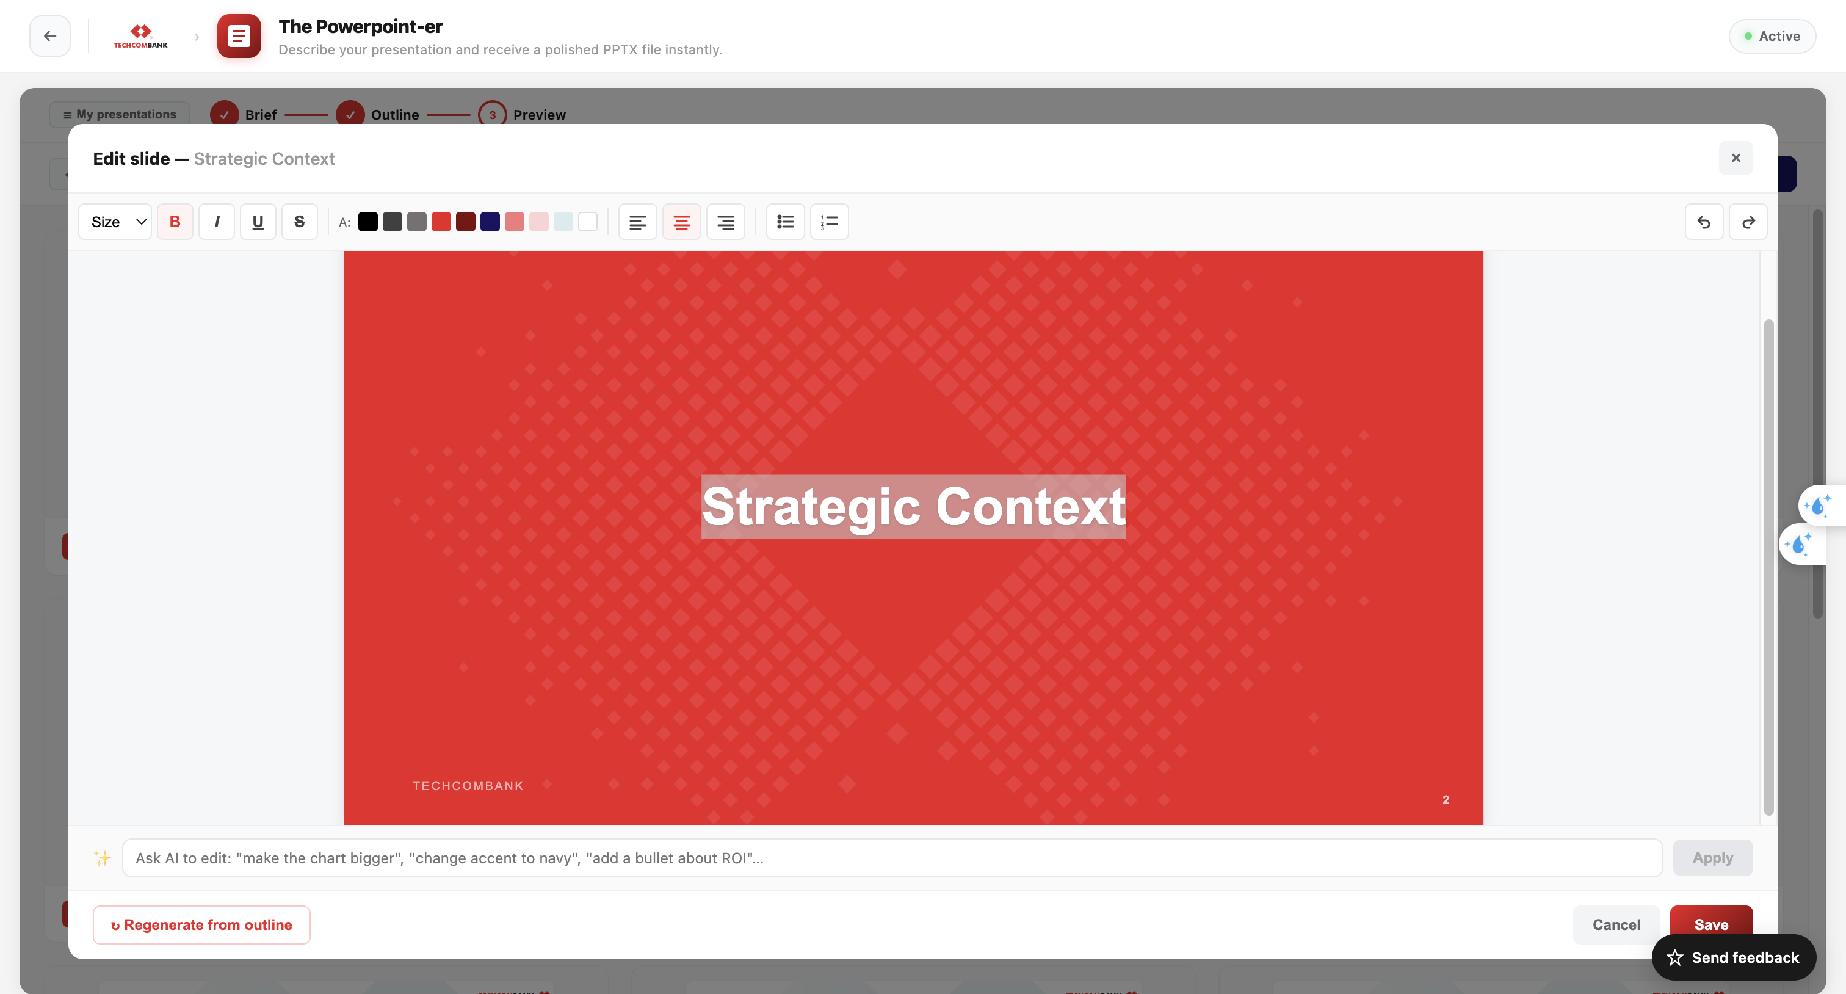
- The top bar provides quick editing actions, including adjusting font size, text color, formatting, alignment, and adding bullet points to the content.
- The “Ask AI to edit” field allows a short description of the desired changes. This helps guide AI to update the content more accurately.
- Click “Save” to apply the edit or “Cancel” to discard changes
- If changes have been saved but the original output is needed again, click “Regenerate from outline” to restore the initial generated version.

Step 5: Export
Choose your export format:
- PPTX — Native PowerPoint file with editable text, vector graphics, and speaker notes
- PDF — Image-based PDF (visual fidelity, text not selectable)
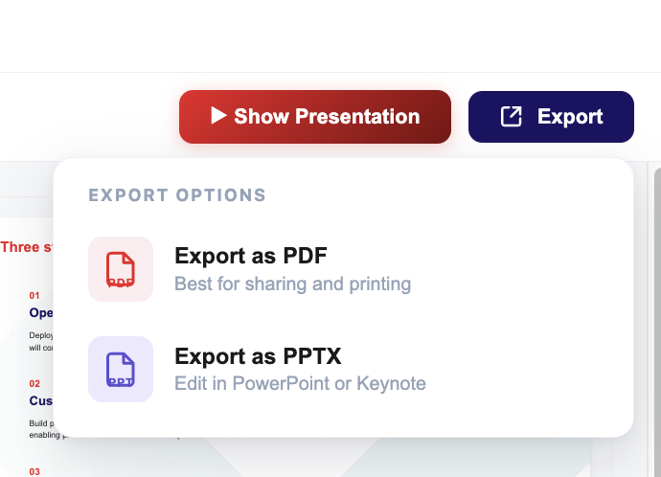
The export runs entirely in your browser. A progress overlay shows the export status.
The homepage of PowerPoint-er displays all previously saved presentations, click “Open” to see fully.
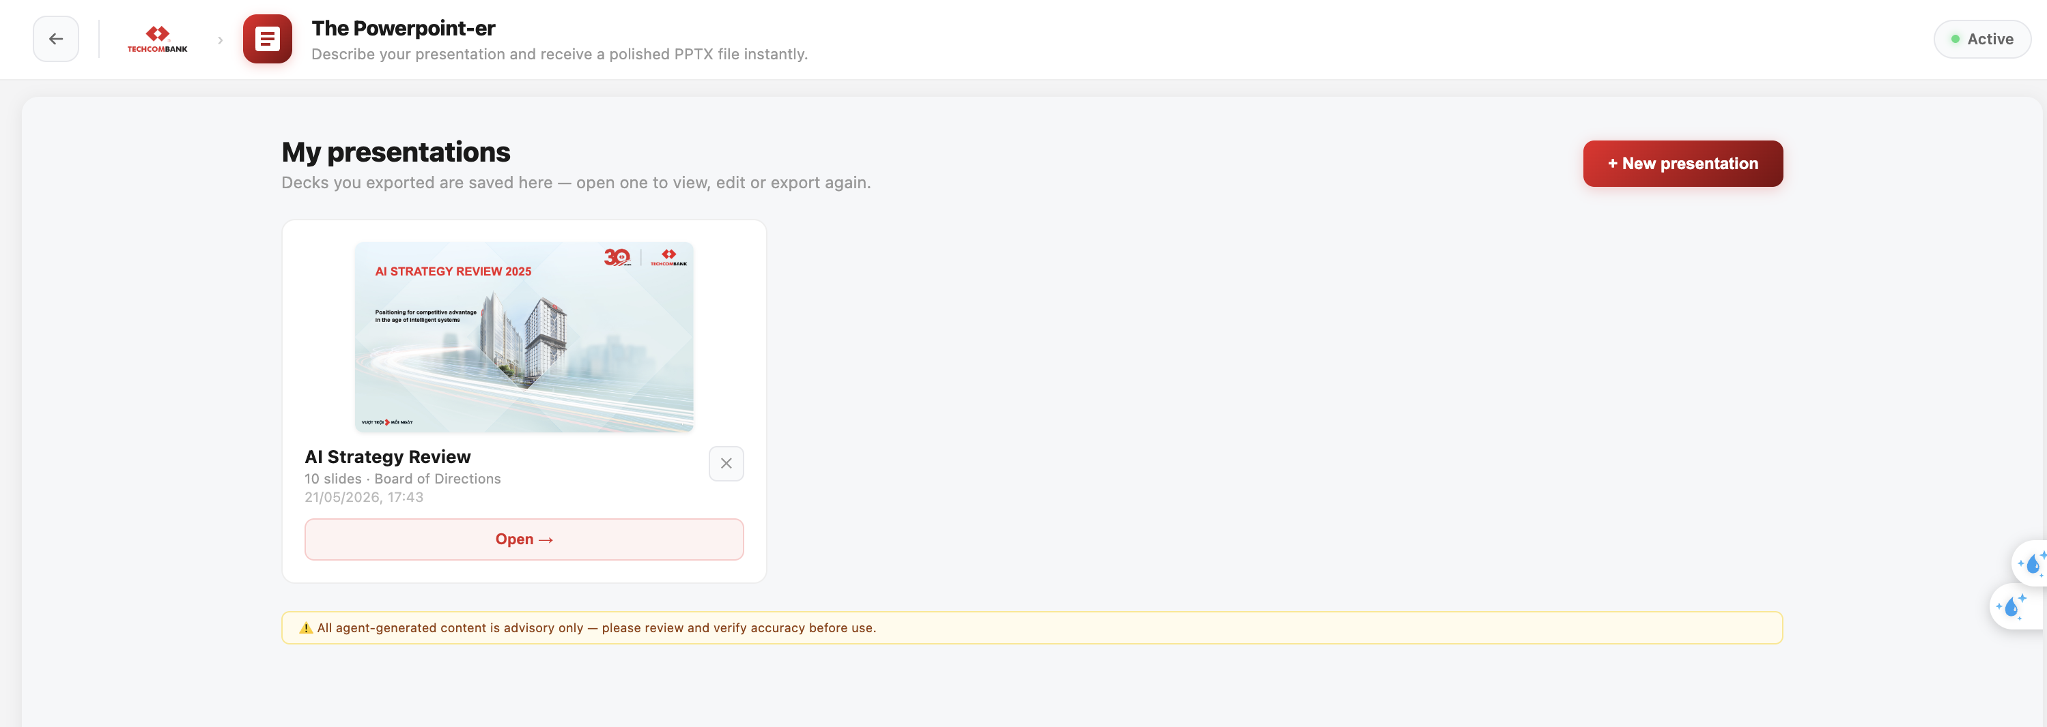
──────────────────────────────────────────────────

Features
- Branded templates — Slides use Techcombank's visual identity
- Speaker notes — AI generates notes for each slide, injected into the PPTX
- Editable output — PPTX contains native shapes and text (not images)
- Browser-side export — No server round-trip for the final file
- Live preview — See exactly how slides will look before exporting
──────────────────────────────────────────────────

Tips
- Be specific in your brief — the more detail you provide, the better the output
- Edit the outline before building — it's much faster than regenerating
- Use the speaker notes for presentation preparation
- For complex presentations, break them into sections and describe each
- The AI handles Vietnamese and English content equally well
──────────────────────────────────────────────────

Limitations
- Layouts depend on bundled templates — no custom animations or complex charts
- Very long presentations (30+ slides) may take longer to generate
- Image insertion is not supported — slides contain text and vector graphics only
- Adding templates directly is not available; full requirements must be clearly described in text
- During slide editing, only inline content updates are supported. Adding new text boxes or repositioning existing elements is not available
- For advanced adjustments, required export and download the PowerPoint file for local editing
- Export requires a modern browser (Chrome, Edge, Firefox)
──────────────────────────────────────────────────
Last updated: 2026-05-28

